**DAILY ONLINE ACTIVITIES SUMMARY**

|  |  |  |  |  |  |  |  |
| --- | --- | --- | --- | --- | --- | --- | --- |
| **Date:** | 08/06/2020 | | | | **Name:** | AMBIKA V | |
| **Sem & Sec** | 4th Sem Section'A' | | | | **USN:** | 4AL18CS005 | |
| **Online Test Summary** | | | | | | | |
| **Subject** | | Complex analysis,probability and statistical method | | | | | |
| **Max. Marks** | | 30 | | **Score** | | 18 | |
| **Certification Course Summary** | | | | | | | |
| **Course** | 1.JAVA PROGRAMMING  2.One day Webinar on E-commerce 101 | | | | | | |
| **Certificate Provider** | | | 1.greatlearning academy  2.Organised by IIDE | **Duration** | | | 3.5 hrs  2 hrs |
| **Coding Challenges** | | | | | | | |
| **Problem statement 1:**Write a Java Program to check whether the given matrix is magic square or not**.**  **Problem statement 2** : C Program to Generate All the Set Partitions of n Numbers Beginning from 1 and so on | | | | | | | |
| **Status:** completed | | | | | | | |
| **Uploaded the report in Github** | | | | yes | | | |
| **If yes Repository name** | | | | https://github.com/ambika0202/lockdown-coding- | | | |
| **Uploaded the report in slack** | | | | yes | | | |

**ONLINE TEST DETAILS:**  Maths test was scheduled from 09:30 am to 10:10 am .The portion for the IA was module 2 there were 30 questions and the time assigned was 40 minutes the questions were mcq type.

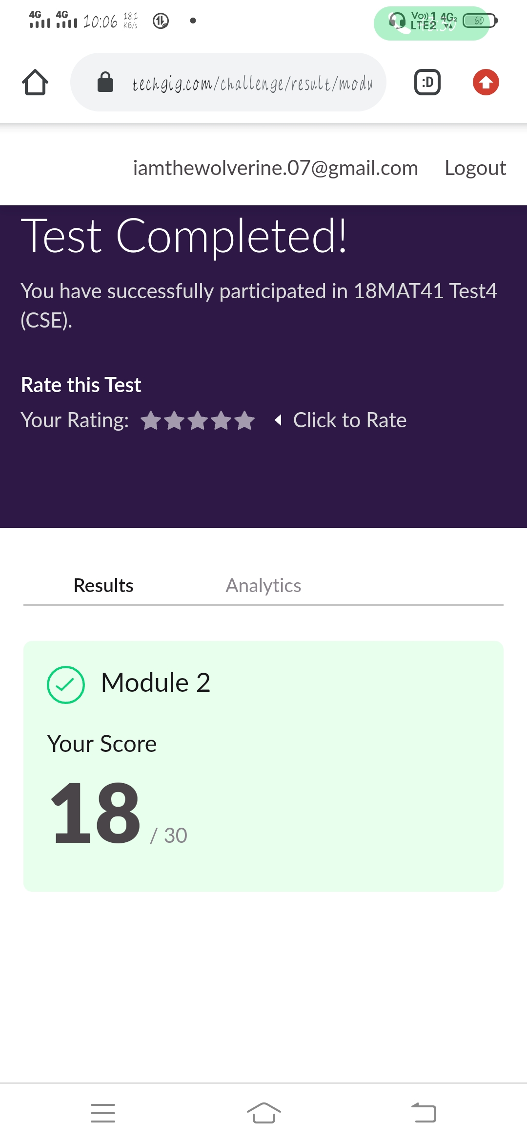

**CERTIFICATION COURSE DETAILS:**

**Name of the course**: Java Programming

**Certificate Provider**: Great Learning Academy

In this Java programming course ,today I have completed all the topics and attempted quiz and scored 8/10 and received its certificate successfully.

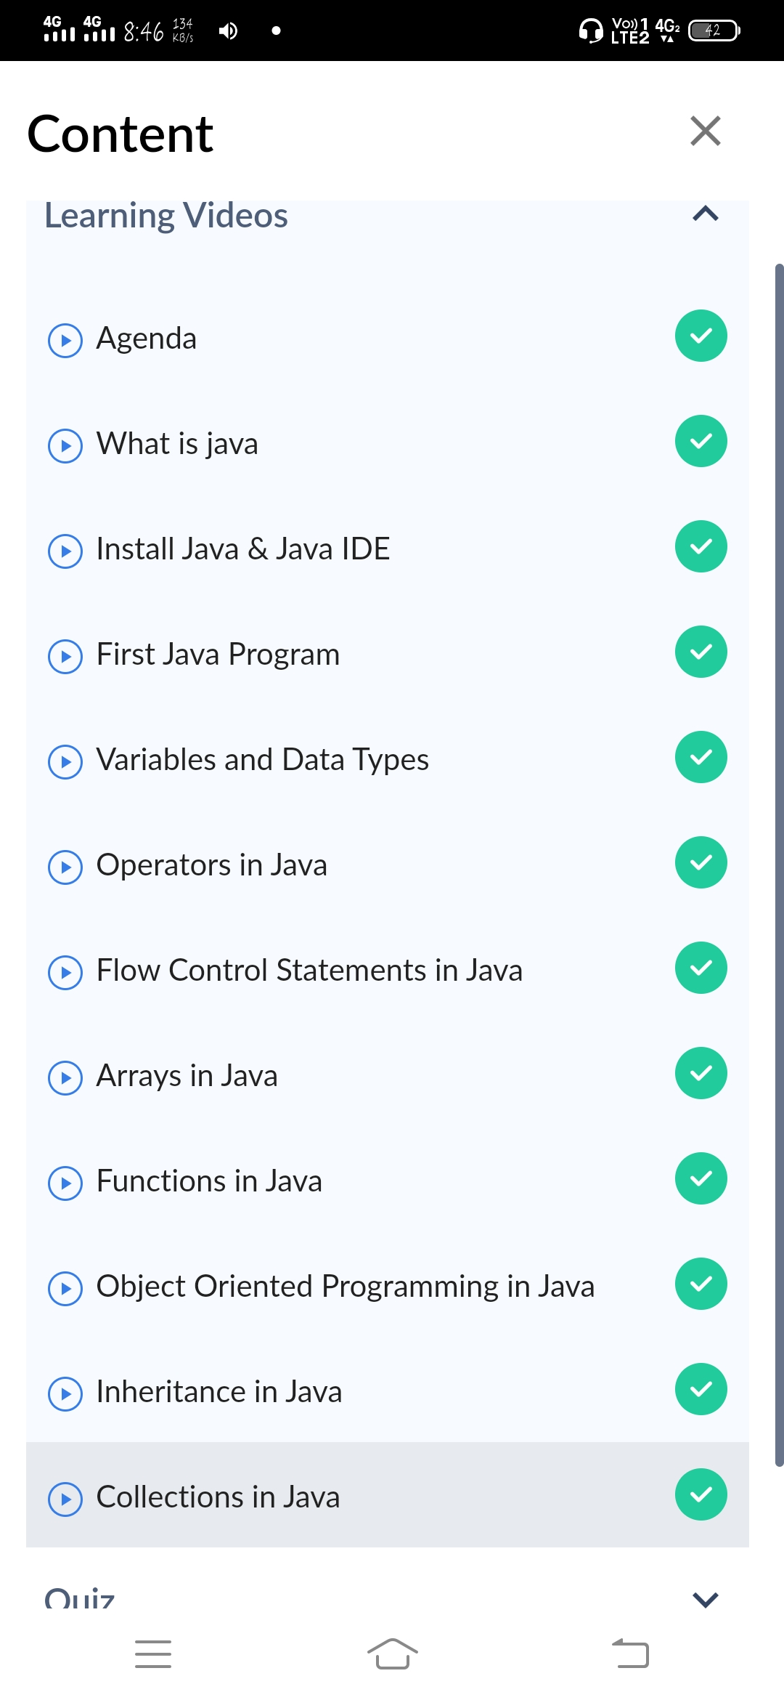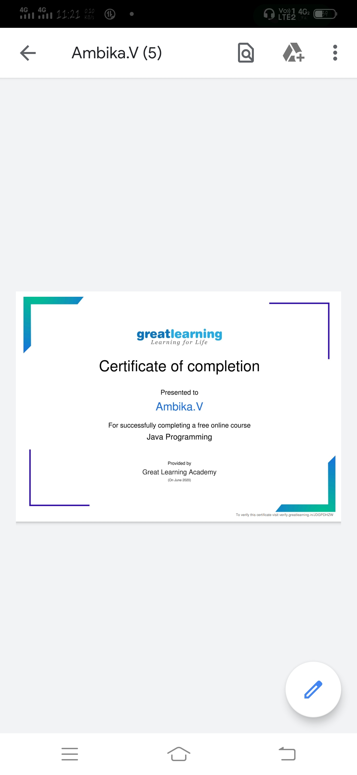

IIDE Organized a special session on E-commerce 101 where wwe can learn how to set up online store in less than 2 hours and market it using social media. Date- 8th June 2020 and Time - 11 AM to 1 PM

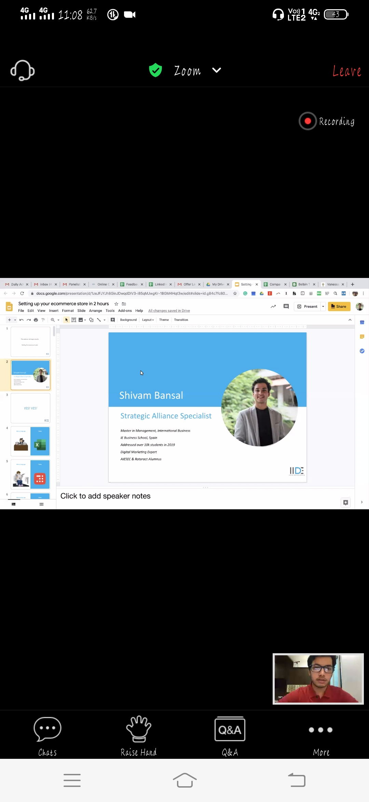

**CODING CHALLENGES DETAILS**: Every day we are given with new question of coding related to the language of java and c.

**Problem statement 1:**: C Program to Generate All the Set Partitions of n Numbers Beginning from 1 and so on

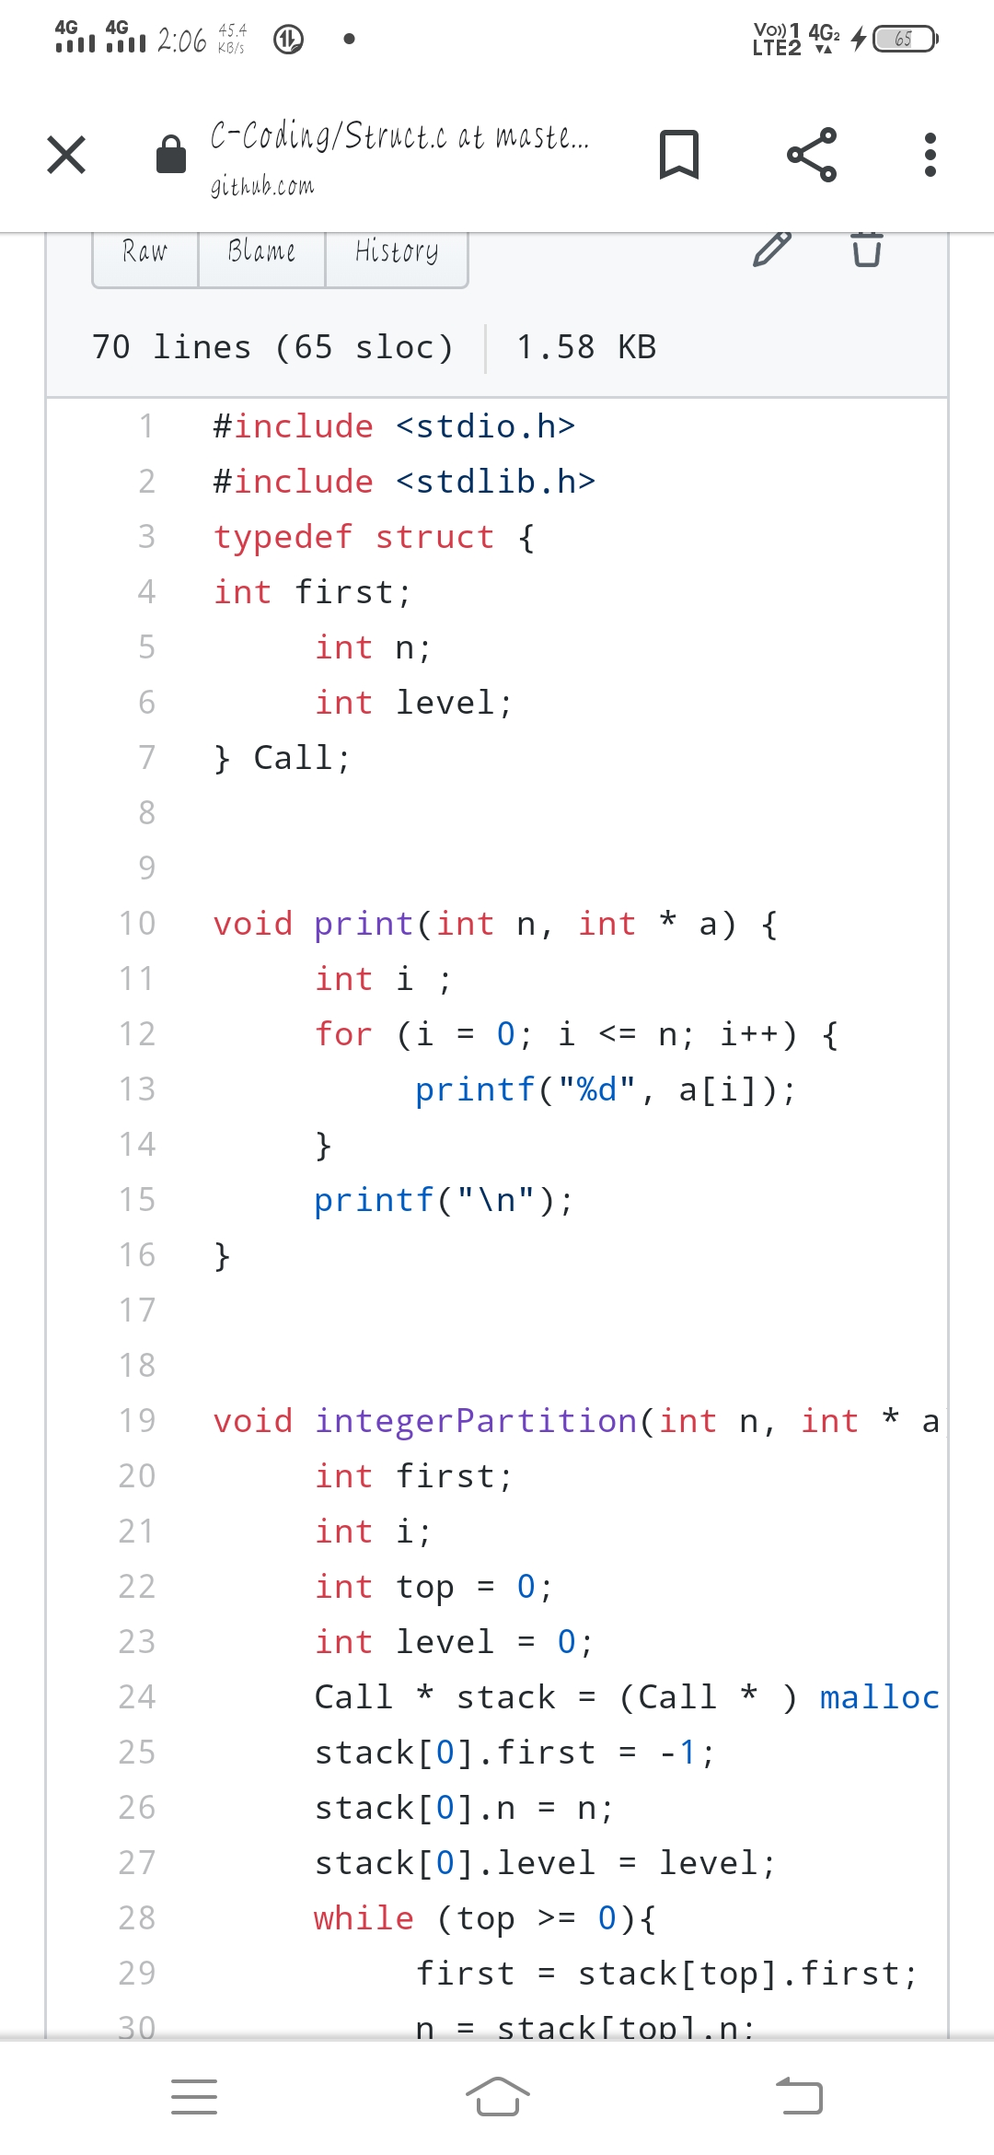

**Problem statement 2:** Write a Java Program to check whether the given matrix is magic square or not**.**

